|  |
| --- |
| Synthetic document |
| WM Fixing Tracking : |
| optimum control based on mean variance framework |

|  |
| --- |
| LI Yangling  2015-6-23 |

# **Summary**

Summary 1

Introduction 2

## Introduction

The WMR Fix was key financial benchmark which was well known as the ‘London 4 pm Fix’ or just ‘Fix’. Bloomberg News reported a scandal concerning Fix manipulation at Jun 2013, since then there is continually demand in robust algorithm which could help clients track the Fix. According to WMR websites, the methodology is :

Over a one-minute Fix period, bid and offer order rates from the order matching systems and actual trades executed are captured every second from 30 seconds before to 30 seconds after the time of the Fix. Trading occurs in milliseconds on the trading platforms and therefore not every trade or order is captured, just a sample. Trades are identified as a bid or offer and a spread is applied to calculate the opposite bid or offer. Using valid rates over the Fix period, the median bid and offer are calculated independently and then the mid rate is calculated from these median bid and offer rates, resulting in a mid trade rate and a mid order rate. A spread is then applied to calculate a new trade rate bid and offer and a new order rate bid and offer. Subject to a minimum number of valid trades being captured over the Fix period, these new trade rates are used for the Fix; if there are insufficient trade rates, the new order rates are used for the Fix

The key difficulties is to find analytical solutions for price median. In this article, we use arithmetical price average to approach median which brings extremely simple solutions under frame-work of almegren. The article is organized below, the first section verify the robustness of approximation, and the second section will present the general frame work of our work. The third section would raise some examples which lead to analytical solutions.

## The Robustness of using average to approach median

Median is well known for its robustness to outlier compared to average. However, the use of median generally makes models difficult to solve. In this section we will present the robustness of using arithmetical average instead of median for Brownian motion in both practical simulations and theoretical prove.

Suppose that the price following Brownian motion in the form below:

$$dS_{t}=σdB_{t}$$

Here we assume that $σ$ is constant for simplicity. The main conclusion is listed below:

* Arithmetical average is non biased estimator for Median
* The estimator can explain most of variance for Median
* The relative tracking error is constant with function of $σ$

In this section we use analytical definition of Median for Brownian motion.

$$Mediane={argmin}_{k} \int_{0}^{t}{|K-B_{s}|ds}$$

In this case,

$E\left[Mediane\right]=B_{0}$ =0

To save the page we do not give analytical solution, the idea is to take derivative of the formula and take expectations. The intuition that the expectation is zero is symetrie, for every path there is alaways a sysmetrie path.

For arthmetric average, we got solution below:

$$Average=\int_{0}^{t}{B_{s}}ds$$

$$Averge\sim N(0,t^{3})$$

In this case we have proved that arithmetic average is non biased estimator for Mediane. The First assumption has been well proved.

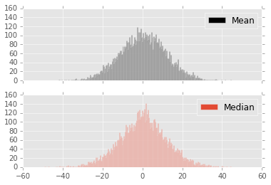

Figure 1 The distribution of arithmetic mean (grey) and median (pink)

|  |  |  |
| --- | --- | --- |
| statistics | Arithmetic mean | Median |
| Average | 0.19 | 0.24 |
| Std | 0.11(theoretical 0.11) | 0.12 |
| Skew | 0 | 0 |
| kurtosis | 0 | 0.34(statistical significant) |

As we could see in the simulation, Median has a bigger kurtosis. This result is intuitive because median is more robust than arithmetical average. However, it should be noticed that there is no much difference between median and AV.

The nature question in this step:

* Can AV explain most of variance for Median?
* How does tracking error involve with volatility?

Because of lacking analytical solution for Median, we present our result majorly by simulation.

by simulation

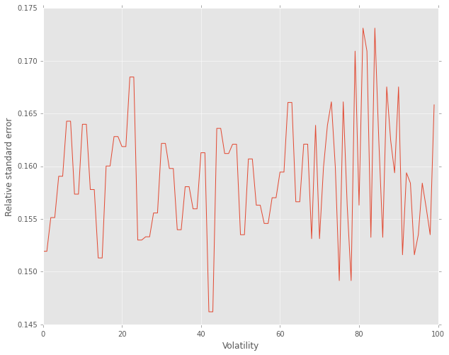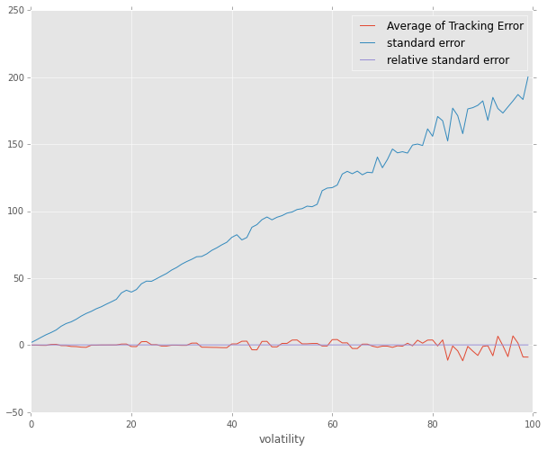

## The Frame work of almengreen

We propose to work at the Frame work of almengreen:

Suppose the stock price and market impact follow,

$$S_{k}=S_{k-1}+στ^{\frac{1}{2}}ξ_{k}-τg (\frac{n_{k}}{τ})$$

$$=S_{0}+στ^{\frac{1}{2}}ξ_{k}-τg (\frac{n_{k}}{τ})$$

In this frame work $S_{k}$ is the stock price sold at time k, $τ$ is the interval while g is permanent market impact function.

The actual price get in kth trade is In fact:

$$\hat{S_{k}}= S_{k-1}-h\left(\frac{n_{k}}{τ}\right)+τ^{-0.5}f\left(\frac{n_{k}}{τ}\right)*\hat{ξ_{k}}$$

Where h represents temporary market impact function. So the average price for a given execution strategy equals to,

$$\sum_{k=1}^{N}{n_{k}\hat{S_{k}}}=\sum_{k=1}^{N}{n_{k}[S_{k-1}-h\left(\frac{n_{k}}{τ}\right)+τ^{-0.5}f\left(\frac{n_{k}}{τ}\right)*\hat{ξ_{k}}]}$$

$$=XS_{0}+στ^{0.5}\sum{X_{k}ξ_{k}}-τ\sum_{k=1}^{N}{X_{k}g\left(v_{k}\right)}$$

$$-τ\sum_{k=1}^{N}{v_{k}h\left(v_{k}\right)}+τ^{0.5}\sum{v_{k}f\left(v_{k}\right)ξ_{k}}$$

Different from frame work of almen, The object function in this section is $-\sum{n_{k}\tilde{S_{k}}+\sum{\frac{X_{0}}{T}S_{k-1}}}$. This means, we take the average price as tracking object.

$$C= -\sum{n_{k}\tilde{S_{k}}+\sum{\frac{X_{0}}{T}S_{k-1}}}$$

$$= στ^{0.5}\sum{[\frac{N-k-1}{N}X_{0}-X_{k}]ξ_{k}}-τ\sum_{k=1}^{N}{\left(\frac{N-k-1}{N}X_{0}-X_{k}\right)g\left(v_{k}\right)}+τ\sum_{k=1}^{N}{v_{k}h\left(v_{k}\right)}-τ^{0.5}\sum{v_{k}f\left(v_{k}\right)ξ_{k}}$$

Then we get

$$E\left(C\right)=τ\sum_{k=1}^{N}{\left(\frac{N-k-1}{N}X_{0}-X_{k}\right)g\left(v_{k}\right)}+τ\sum_{k=1}^{N}{v_{k}h\left(v_{k}\right)}$$

$$V\left(C\right)=σ^{2}{ τ}^{}\sum{{\left[\frac{N-k-1}{N}X_{0}-X_{k}\right]}^{2}}+τ^{}\sum{v_{k}^{2}f{\left(v_{k}\right)}^{2}}$$

Pass to continuous form

rformance of 4 Index